

LinkedIn Grad - Start your career

Training Guide for Sales and Customer Support

## **Background:**

Research has shown that over 200 million students graduate each year, whereas just only 51% of them would be hired during 6 months after graduation (2020).

Approximately 100 million freshers would be unemployed, which brings several negative aspects to the economic development worldwide.

LinkedIn is an employment-oriented service, which is used for looking for professional job opportunities popularly in the world.

Recently, there are many similar platforms that focus on the new target users - graduated students every year.

## 

## **Problem Statement:**

Nowadays, there has been an increasing number of companies, which provide job recommendations and excellent features for that mean of users.

Several graduated students have faced a lot of difficulties looking for their first job that is suitable with their professional skills as well as their expectation in the future. The primary reasons are a lack of soft skills like interview or negotiation, no experience in working environment in businesses and career path’s direction.

Struggles with freshers to start a professional career:

* *Lack of work experiences in enterprises’ environments*
* *Lack of soft-skills (interview, communication, …)*
* *Have no clear career paths*

**Product Goals:**

* Build a system help users create and review resume
* Provide numerous online courses and certificate
* Apply AI in suggesting students’ profile to recruiters
* Recommend jobs

## **Market background:**

### LinkedIn Grad will focus on freshers of the global workforce by providing the fundamental step for their career such as an excellent resume, advanced professional and soft skills and the suitable job recommendations.

### **Total Addressable Market**

200M students per year X $120 (annually) = $24B

**Potential Market:**

* China *(27% of global in 2030)*
* India *(23% of global in 2030)*
* US *(8% of global in 2030)*

**Competitors**

1. **Indeed**

| Product Available | * Website * Mobile Application |
| --- | --- |
| Features | * Resume builder * Job listing * Messaging * Email Job Alert |
| Target customers | * Worldwide market |
| Differentiators | * Schedule and conduct virtual interview * Free trial (unlimited) |
| Price | * Free |

1. **Glassdoor**

| Product Available | * Website * Mobile Application |
| --- | --- |
| Features | * Listing jobs * Personal branding * Review company * Access salary databases |
| Target consumers | * Worldwide users |
| Differentiators | * Job satisfaction rate |
| Price | * Free |

## **Product Background:**

Mobile application named LinkedIn Grad provides many features related to enhancing freshers’ skills and preferences. Several benefits can be reaped from our application such as job recommendations, creating and reviewing resumes, and online courses.

**Key Features**

1. **Resume**

* CV’s system for users to upgrade their resume with the suggestion from AI.
* This is a crucial feature to build the fundamental background for users and attract the recruiters.
* Increase the acceptance rate of the 1st round (CV)

1. **Online Course**

* Training courses provide a lot of information for freshers to enhance their professional skills (marketing, computer science,...) and their soft skills (interview, presentation, negotiation, …)
* This is a supportive foundation that helps college graduates be outstanding in the next stages.

1. **Job Recommendation**

* Based on the professional and soft skills as well as the created resume, there are several suggestions about the suitable jobs for students.
* This is a vital step in the process of applying for a job, which could have positive impacts on the result of acceptance rate.
* Feature allows freshers to access the potential career of their aspects and directs them to follow.

**User supports**

Users can download the app from Google Play Store for android OS and App Store for iOS easily and conveniently.

**How to register and login**

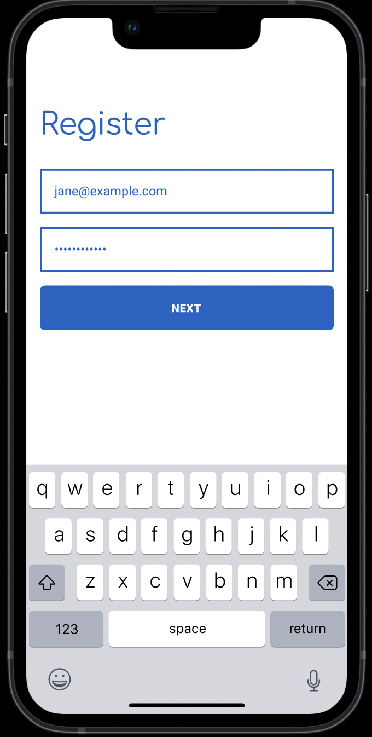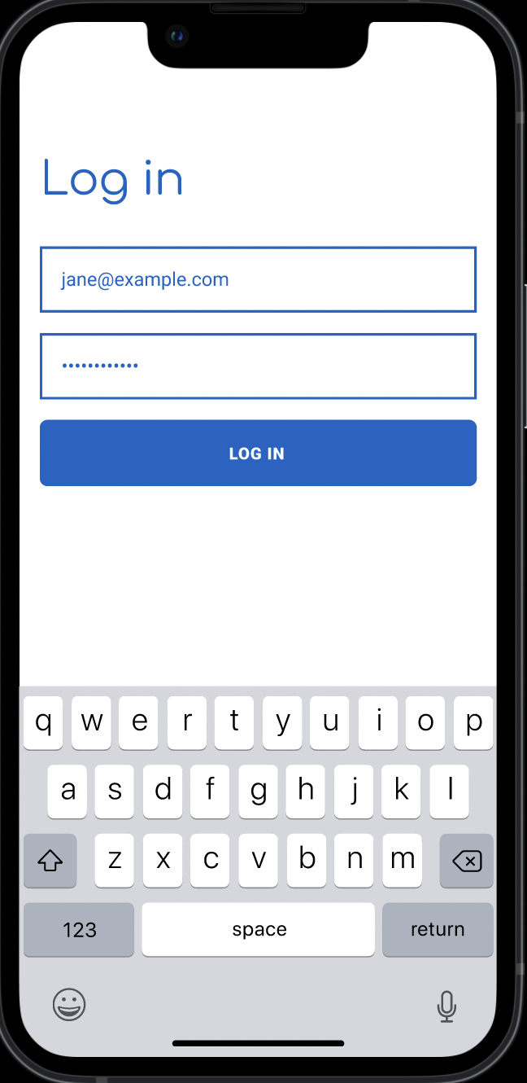

**How to create and review Resume**

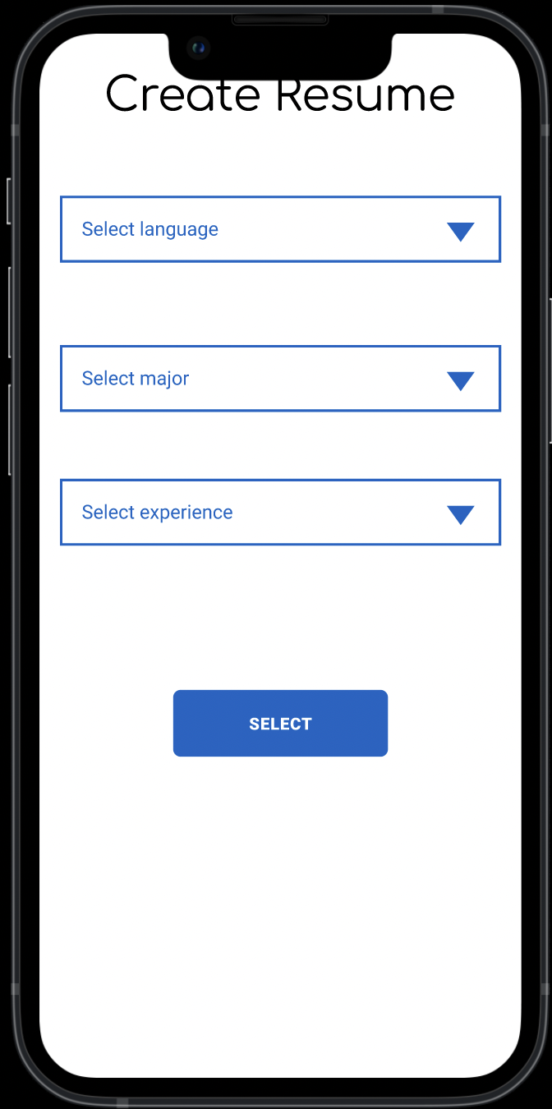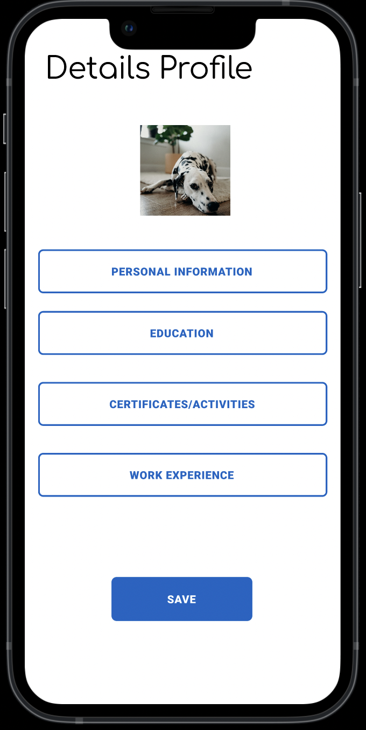

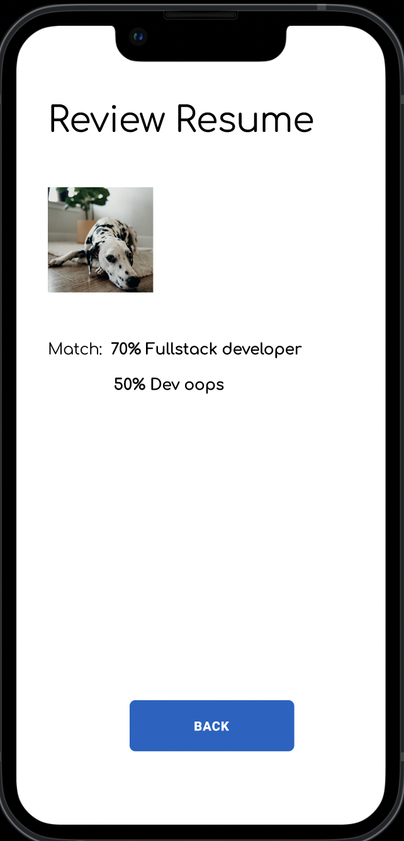

**How to apply a job from recommendation**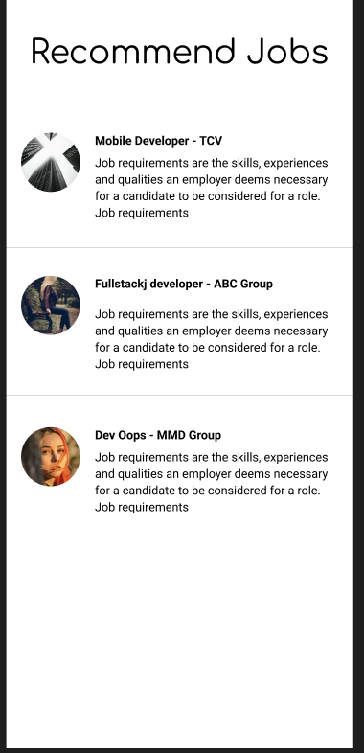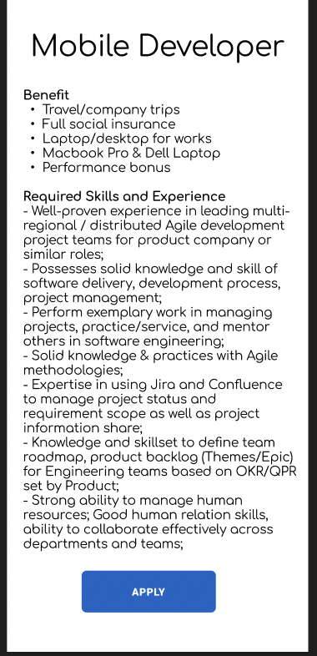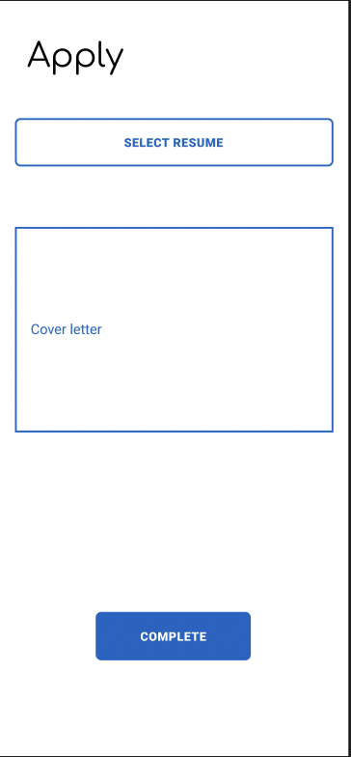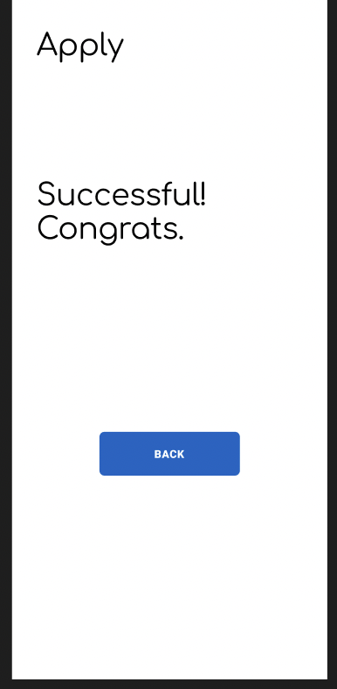

**Current Issues**

* Development team is trying to improve job recommendations and resume reviewing by enhancing the algorithm of AI system to provide better match results
* Partnership team is focusing on finding more online courses through academic platforms to provide more certificates related to professional skills and soft skills.

## **Pricing**:

Users could access some free features such as building profiles and networks, creating resumes and applying for jobs.

However, they need membership to access reviewing resumes by AI systems, online courses, certificates, and job recommendations.

**Premium packages:**

* **1 month: 12$**
* **3 months: 10$**
* **Annual package: 8$**